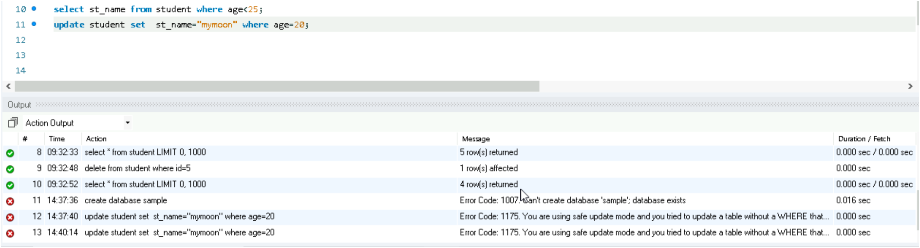sometimes we may face errors while updating some records, This is due to safe update mode. This mode prevents accidental updates or deletions without a WHERE clause that uses a key column.

To solve this problem write the query **SET SQL_SAFE_UPDATES = 0;**

this will disable safe update mode. Then you can write write update query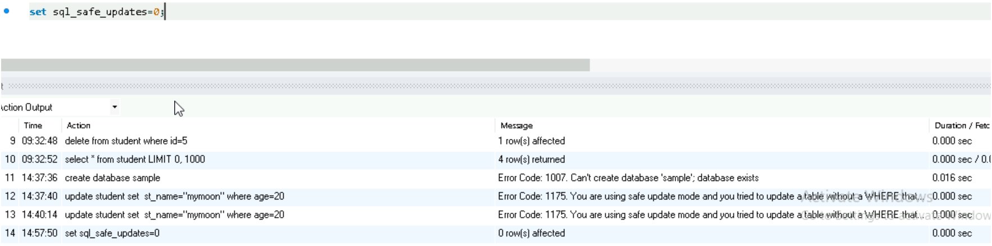



There is a chance to get an error while using **FULL JOIN**. So We find the full join by using another logic,ie the combination of **LEFT JOIN** and **RIGHT JOIN**.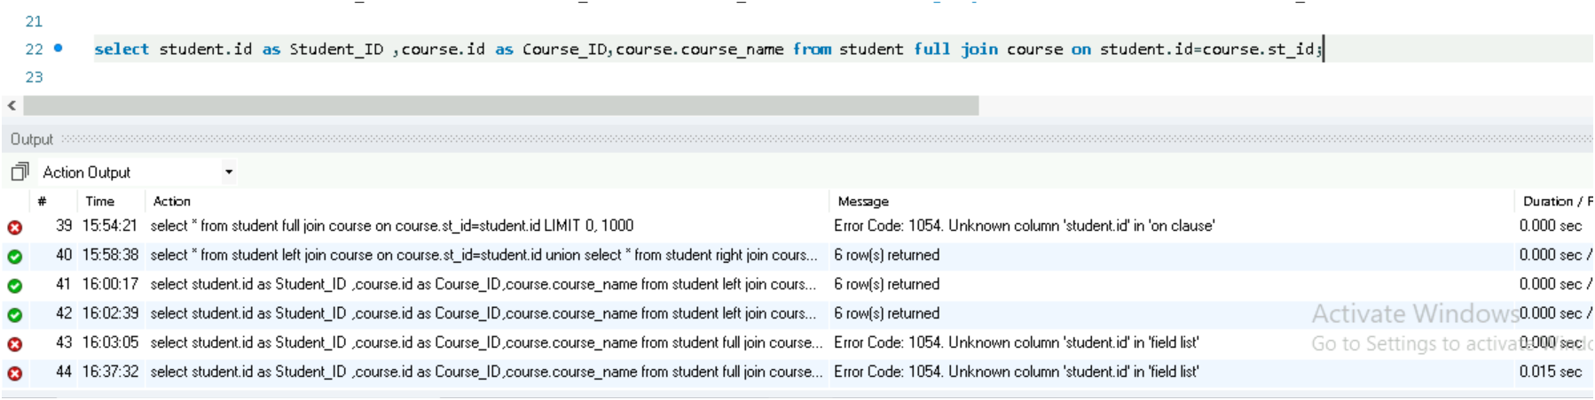

First we need to find **LEFT JOIN** and then find the **RIGHT JOIN**. Combine this into one using **UNION**.

It will preserve the records from **LEFT JOIN** and **RIGHT JOIN**,and common records in both tables while removing the duplicate entries.

